I will go through your document from the beginning page, section by section
First I must apologize for not including the quantity scoring table I only provided that for the worth in the full document.
- The Academic model is very different from the non-academic model so please take note
Academic Model section
There are two points to work out before comparing the output points against a target for the particular cadre under consideration and these are
- Quality: This is obtained from each result from the forms (here you outlined only four forms but they are actually five) which are
1) Student evaluation form
2) Teaching Quality form
3) Research form
4) Administration form
5) Community service form.

The worth of the result from each form is obtained from the worth table. E.g. for Research if the result is 56 it means the worth is 9. Having obtained this the next thing is obtaining the quantity. To determine the quantity we need the Output Quantification Scheme table as provided below for four output types and these are 1) Research Output
2) Teaching Output
3) Administrative Output
4) Community Output

However one is still missing from the above table and that is for student quantity result = BASIC UNITS + 0.02 * (Number of students)
The basic unit here is for the course he/she is taking for that period of Appraisal evaluation

Table ********(output quantification scheme)

S/No | Output Category | Units of Output | Type
1 | Published papers in refereed journals or proceedings | 7 units per page | Research OUTPUT
2 | Published Books | 0.01 Units per page of text-standard book
3 | Patents, Designs, Prototypes etc. | 1 to 4 UNITS of certified work depending on degree of Sophistication
4 | Monographs, Technical paper, Research Report, Conference Papers, Abstracts etc. | 0.02 UNIT per page of certified copy
5 | a) Theoretical Subject taught  b) Practical/Clinical demonstrations, etc. | 1 UNIT per 15 semester hours plus 0.02 UNIT per assessed student scripts etc.  1 UNIT per 45 semester hours plus 0.02 UNIT per assessed student work or script | Teaching OUTPUT
6 | Administration and Community Services Output | 0.02 per page of documented evidence | Certified Administration and Community Services Output

These two values will help us in determining the value of output.
You will notice that why all other forms data are to be inputted by the appraisee the Student evaluation form is to be handled by the registered departmental admin staff registered in the software. The Observed Output = Quantity x worth
This will be summed for all the five categories (Student, Teaching, Research, Administration and Community)
The people and Office Section
The HOD should see the final score scored from each form result and can either approve the score or reject the score by providing his own score and supporting this with his justification. Please the office of the Dean has nothing to do here except when evaluating the data of the non-academic staff under his department. Apart from this he is to sign in as a normal staff under his department and perform his appraisal as a staff under his department. Another area here with concern is the External or peer examiner section. I will suggest that the Admin staff in the department handles this as well just as he/she does for the student evaluation of his/her particular course lecturer.

Structure and Timing Section
The Appraisal period should be subject to setting by the Estab./Personnel unit/department (This could be yearly Bi-annual, or Quarterly.)

Scoring Section
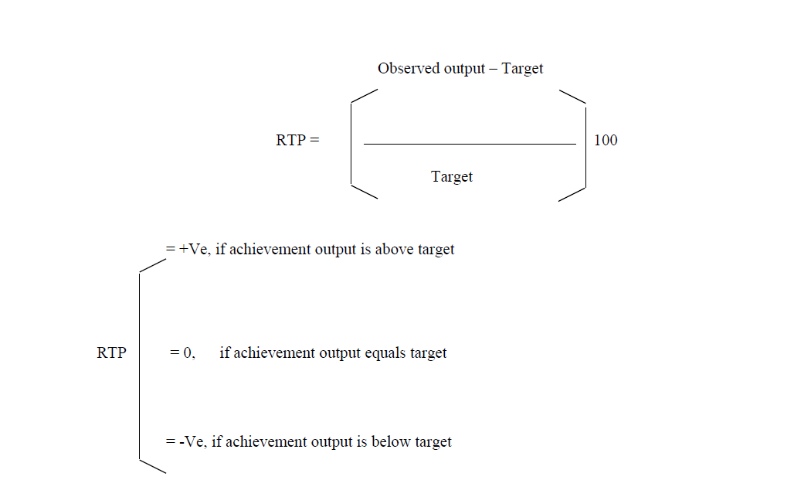
To the RTP grades this helps us to rightfully apply the motivation model where certificated barges, Books of records (1st and 2nd ), and Hall of fame, or even reprimand will be applied to the staff that falls within the grades. See a tree structure that explains this below:

PERFORMANCE GRADES

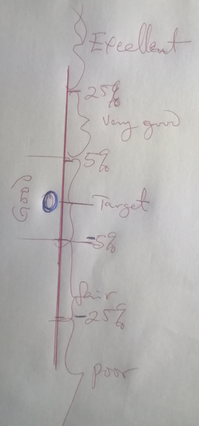
The tolerance band: please give it a name of your own but note that this is not to be made known to any of the subjects (Staff or HOD) it is within the system model to be run in the background and when
flagged this is only to be made known to the super admin(i.e. the Organization admin) the
worth table is also to be run in the background and not to be made known to any user (including the super Admin/Organization admin)

HOW A SCORE IS CALCULATED
Student quantity result = BASIC UNITS + 0.02 * (Number of students) is for the student form
For the other forms we are to use the Table ****(output quantification scheme) in computing their quantity results

All the other formula is explicit enough to understand

For the Dean under the Deans platform he/she can only approve each departments submitted result for the Estab./Personnel department to give the final go ahead to the Super Admin/Organization admin to do the final evaluation.

NON-ACADEMIC APPRAISAL
For this the non-academic appraisal we only perform the mean obtained from the three forms. We then determine the worth of the Mean results from the forms from the worth table and this will now be used to multiply the mean result obtained from the three forms to obtain the output score. This score will now be evaluated against the Target for the cadre of the staff to obtain the RTP just as found with that of Academic staff.
Output score = Mean (3 forms results) x its worth (or the Mean result).



Please multiply the Target by 2 in the where it surfaced under the RTP determination
RTP = [(Observed Output – 2xTarget)/2xTarget]
This is only for Non-academic staff.

PERFORMANCE GRADES



I will supply a template for the Non-academic staff cadre Target Scheme later

WHAT ALREADY EXISTS IN THE SOFTWARE
Please check all the already built elements and confirm they are rightly built.

OPEN QUESTIONS
- What is presented at page 95 have been re-presented above, actually what you have there is for the performance model which you will be visiting next.
- This have been presented in the tree form above
- For academic staff, the five forms in the categories result obtained after their output values each has been computed are summed up together to get their combined observed outputs and their corresponding targets are also summed up and use to determine the combined target which is eventually used to get the RTP



For the non-academic staff we determine the worth of the Mean results from the forms from the worth table and this will now be used to multiply the mean result obtained from the three forms to obtain the output score. This score will now be evaluated against the Target for the cadre of the staff to obtain the RTP just as found with that of Academic staff.
Output score = Mean (3 forms results) x its worth (or the Mean result). After which the tree performance grading is applied.

- Targets are fixed for the academic staff model. I will provide that for the Non-academic staff model which should also be fixed.
- I will provide it before 10 am tomorrow morning.
- What I mean by “Do not store” here is that the only condition where after a the HOD’s suggestion and the staff accepts it (the system then does a computation as described in the document) but where the staff rejects the HOD’s suggestion that score shouldn’t be registered in the system database yet but be pulled aside for the external auditor to investigate into and provide his/her final score which is to be recorded in the system software.
- It should be 10 and nothing less as far as the number of students for the course is more than 10. Under data analysis 10 or 15 minimum data is required for a computation to be made. Please note that it’s the mean of these 10 that is recorded as the final result for student evaluation for that staff.

